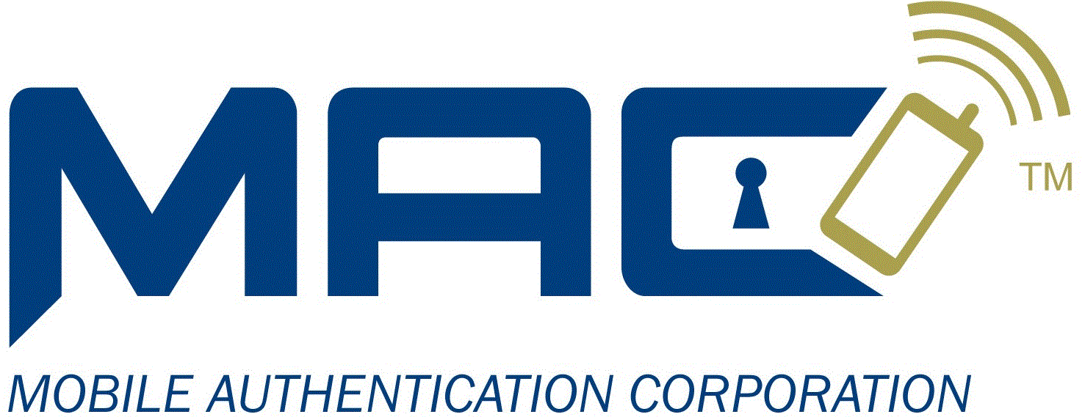

|  |
| --- |
|  |
| Mobile Authentication Corporation |
| Secure Trading / Mobile Authentication Corporation Scope Of Work, Version 1.0 |

|  |
| --- |
|  |

# Introduction

Mobile Authentication Corporation (“MAC”) provides an Out-Of-Band, One-Time Password (OTP) solution that provides End User authentication and payment transaction verification of financial transactions.  The MAC OTP system is designed to be integrated into existing payment processes. It is comprised of a set of Web Services that provide the needed functionally to deliver OTPs to the End User’s mobile device and to verify the End User’s entered OTP.

The Initial Development Project set forth in this Statement of Work #1, of the Agreement, is designed to integrate MAC’s OTP services into the Secure Trading System’s ???????.

This integration will result in two(2) solutions, a “Fully Integrated Solution” and an “User Registration Solution” and enable:

1. Fully Integrated Solution, Secure Trading the added security provided by MAC’s OTP service to authenticate End Users, who are logging into their account and to verify funds movement request transaction using two-factor authentication by delivering an OTP via SMS text to the End User’s mobile phone.
2. User Registration Solution , MAC the ability to use Secure Trading System’s User Enrolment and User Verification features to verify user information as part of the MAC’s Registration process.

Contents

Contained in this document are Overview Diagrams for each solution to provide a visual context for the solution and a list of work items for each company.

**Out of Scope**

* Testing of MAC’s OTP Registration Authority or AdPass.
* Financial reconciliation, settlement, and other back-office functions.
* Integration of the MAC OTP service via the TNSPay Direct API, Hosted Payment Form, Merchant Administration, or other TNSPay Gateway integration methods as may be offered from time to time

**Project Documentation**

Both parties understand and agree that STS will produce no custom documentation for MAC in connection with the Initial Development Project set forth in this SOW #1.

**Assumptions**

In undertaking the work detailed in this SOW #1, TNS assumes and relies upon the following statements:

1. OTP authentication is performed before payment processing.
2. Merchants may not request to bypass OTP services on a per transaction basis.
3. Certification of the integration to MAC is a simple process, which can be completed in one to two (1-2) business days.

# Full Integrated Solution

## Overview diagram

The Full Integration Solution will be designed to add the MAC One=Time Password to Secure Trading Systems product as an add on option.

## Secure Trading System Work Items

Secure Trading System will be responsible for the following work items:

1. Create a test environment that is configured to communicate with MAC’s test system.

## Mobile Authentication Corporation Work Items

1. Create a service that the STS system can call to register an end user:
2. Create a service that the STS system can call to get the usage and billing information:
3. Create a service that the STS system can call to request an OTP be sent:
4. Create a service that the STS system can call to verify an OTP:

# User Registration Solution

## Overview diagram

## Secure Trading System Work Items

Secure Trading System will be responsible for the following work items:

## Mobile Authentication Corporation Work Items

# Change History

V1.0 - Original document